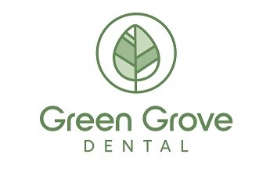

Pre-Sedation Patient Instructions

Please follow these instructions to prepare for treatment with IV Sedation

Food and Beverages
- Nothing to eat or drink for 8 hours prior to dental procedure with the exception of water and clear fluids (apple juice, Gatorade, tea, black coffee or water, but not alcohol).
- Stop drinking clear fluids two (2) hours prior to dental procedure

Medications
• It is essential to discuss with your dentist whether or not you should take medication(s) you otherwise take on a regular basis. Please provide a current list

Clothing
- Please wear loose fitting clothing with sleeves that can be rolled up past the elbow (e.g., short sleeve t-shirt)
- Contact lenses and jewelry must be removed at the time of surgery
- Do not wear lipstick, excessive makeup, or nail polish on the day of surgery

Smoking
• Refrain from smoking for at least 12 hours prior to treatment.

Transportation
- Under no conditions can you drive yourself home. A responsible adult must drive the patient home, and stay with the patient for the whole day
- The patient should not drive a vehicle or operate any machinery for 24 hours following anesthesia. You are considered legally impaired and cannot drive for 24 hours after receiving anesthesia
- Arrange time off work or school as you will need time to rest and heal
Appointment date and Time: ____________________________

